## Enterprise Content Management

**Lab Time:** 45 minutes

**Lab Folder**: C:\Student\Labs\ECM

**Lab Overview:** In this lab you will work with some of the new capabilities added to SharePoint Server 2010 in the area of Enterprise Content Management. First, you will verify (or implement) the configuration of a Managed Metadata in a SharePoint Web application. Then you will customize the Managed Metadata term store and leverage it within existing or new SharePoint sites. Next you’ll implement document sets, a new capability in SharePoint Server 2010 Enterprise Content Management.

**Lab Setup Requirements**

* Before you begin this lab, you must run the batch file named **SetupLab.bat** located in the folder for this lab. This batch file runs a PowerShell script which creates a new SharePoint site collection at the location **http://intranet.wingtip.com/sites/ECM**.

### Exercise 1: Working with Managed Metadata

In this exercise you will configure the Managed Metadata service application and leverage the metadata within a SharePoint list.

1. Managed Metadata service applications, as with all service applications, are configured at the farm level. First make sure the **Metadata Web Service** is running by going to SharePoint **Central Administration » System Settings » Manage Services on Server** (under **Services**). If the status is **Not Started**, click **Start** to the right of the **Managed Metadata Web Service** service.
2. From **Central Administration**, select **Application Management » Manage Service Applications** (under **Service Applications**).
3. Select the **Managed Metadata Service** service application that has the type **Managed Metadata Service** and from the ribbon, select **Manage**.
4. Before doing any management, you need to add yourself as a term store administrator. Enter **administrator** in the **Term Store Administrators** field, validate the name by clicking the person icon and click **Save**.

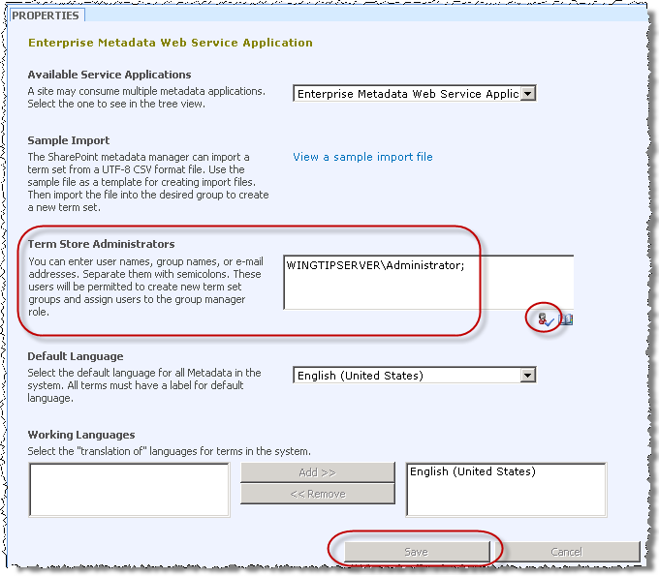

1. Create a new term store group by selecting **Managed Metadata Service** in the tree view and selecting **New Group**. Give the group a name of **Locations**.

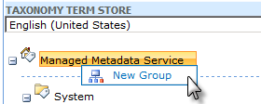

1. Within the **Locations** group, create two new **Term Sets** using the context menu technique in the previous step: **North America** and **Europe**.
2. Within **North America**, create terms and child terms using the context menus on each node in the tree to create a structure like the following:

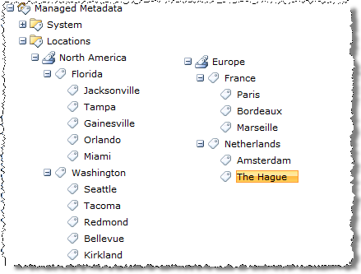

1. Now, add synonyms for some of the cities listed… these will be airport codes. To enter synonyms, pick a term and in the **Properties** pane on the right, enter the synonym on the **Other Labels** section like so:

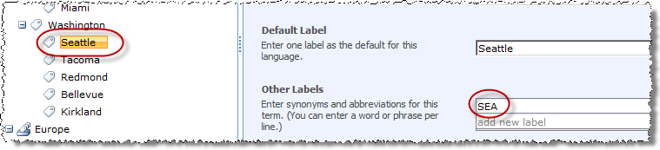

1. Use the following table to add a few synonyms:

|  |  |
| --- | --- |
| **Term** | **Synonym** |
| Seattle | SEA |
| Jacksonville | JAX |
| Tampa | TPA |
| Orlando | MCO |
| Miami | MIA |
| Gainesville | GNV |

1. With a term store configured with some sample tags, to provide real value it can be leveraged within a SharePoint list among many other areas. Go to a SharePoint site (http://intranet.wingtip.com/sites/ECM). Create a new list named **Employees** by selecting **Site Actions » More Options**, then select the **Custom List** template.
2. Edit the list to add columns by clicking the **List** tab in the ribbon, selecting **Settings** and then **List Settings**:

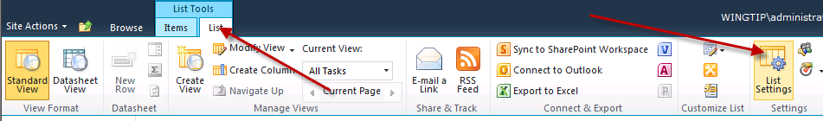

1. Now create a new column for this list using the **Create column** link below the **Columns** section of the **List Settings** page. Use the following information to complete the new column form, leaving all other fields as their default values:

**Name**: Home Town

**Type of information in this column is**: Managed Metadata

Display the entire path to the term in the field:

Use a managed term set and pick **Managed Metadata Service » Locations » North America**.

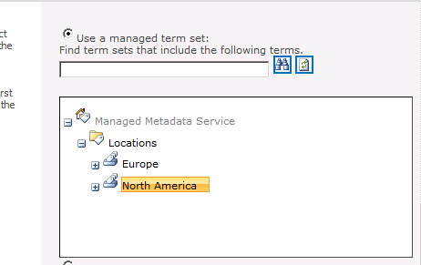

1. Click the **OK** button to save the new column.
2. Go back to the list by clicking **Employees** in the breadcrumb at the top of the page. Now add a new item to the list. This is done using the Ribbon again. Select the **Items** tab, then **New Item** and finally **New Item** as shown in the following figure.

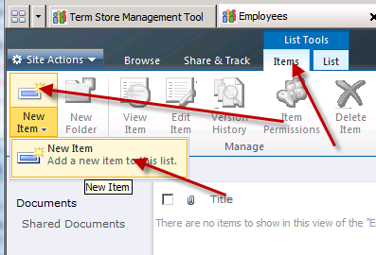

1. Enter any name in the **Title** field. In the **Home Town** field, start typing **Seattle**, but don’t type the whole thing. Instead, pause for a moment and watch the field control attempt an auto complete (and include part of the term’s hierarchy).

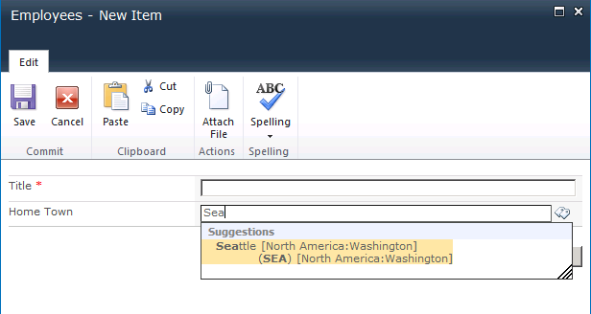

In this exercise you created a taxonomy that can be used throughout the farm.

### Exercise 2: Working with Document Sets

In this exercise you will add the capability to create documents sets within a SharePoint site and interact with the document set.

1. Launch the Internet Explorer and navigate to the top-level site at http://intranet.wingtip.com/sites/ECM.
2. The first step is to enable the document sets Feature. Click **Site Actions » Site Settings » Site collection features** (under **Site Collection Administration**) and click **Activate** next to **Document Sets**.
3. With the document set capability enabled, next step is to create a custom document set. Navigate to **Site Actions » Site Settings » Site Content Types**. The document set you’ll create is for new product specs. Over the next few steps you will create several content types.
4. Create the first content type with the following settings:

**Name**: Product Spec Details

**Parent content type group**: Document Content Types

**Parent content type**: Document

**New group:** My Doc Sets

Go to **Content type settings » Advanced Settings** and upload the document template ProductSpec.docx that is provided in the **StarterFiles** folder for this lab.

1. Create the second content type with the following settings:

**Name:** Product Spec Budget

**Parent content type group**: Document Content Types

**Parent content type**: Document

**Existing group**: My Doc Sets

Go to **Content type settings > Advanced Settings** and upload the document template ProductBudget.xlsx that is provided in the folder for this lab.

**Note:** Now you can create the document set. Document sets are represented as folders in the user interface, but they are based on the Document Set content type.

1. Create a new content type for the document set with the following settings:

**Name**: Product Spec

**Parent content type group**: Document Set Content Types

**Parent content type**: Document Set

**Existing group**: My Doc Sets

* 1. Go to content type settings.
  2. Create a new column named **Program Manager** based on the type **Single line of text**.
  3. Create a new column named **Lead Developer** based on the type **Single line of text**.
  4. Create a new column named **Lead Tester** based on the type **Single line of text**.
  5. Go to **Content type settings » Document Set Settings**.
  6. **Allowed Content Types**: Add the two content types previously created: **Product Spec Details** and **Product Spec Budget**.
  7. **Default Content:** add the ProductSpec.docx (content type: **Product Spec Details**) and ProductBudget.xlsx (content type: **Product Spec Budget**) provided in the sample files associated with this lab.

1. Remove Document as Default content type
2. Remove Document as allowed content type

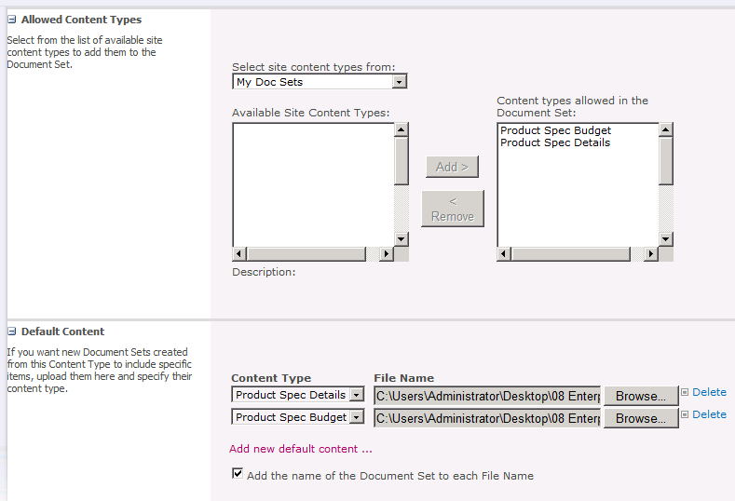

1. **Shared Columns**: check the **Program Manager**, **Lead Developer** & **Lead Tester**.
2. **Welcome Page Columns**: add the three columns available to the columns shown in the welcome page.

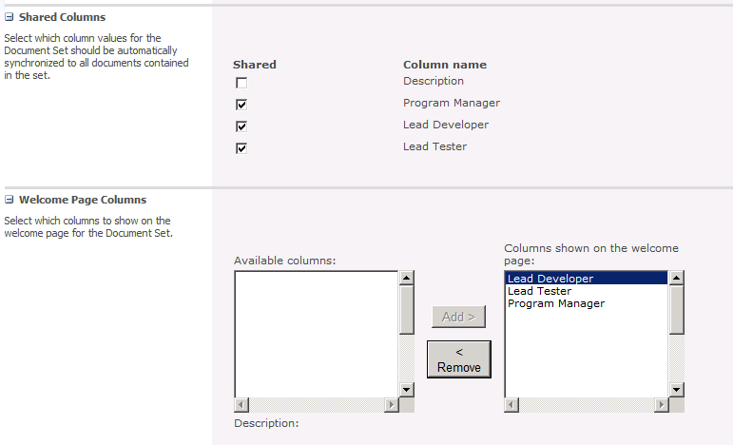

1. Click the **OK** button.
2. Now, with the **Product Spec** document set created, go back to the http://intranet.wingtip.com/sites/ECM site you’re in and create a new document library: **Site Actions » New Document Library**. Give it the name of **Product Planning**.
3. With the list created, you now need to do some extra configuration. Edit the list to configure content types by clicking the **Library** tab in the Ribbon, selecting **Settings** and then **Library Settings**:

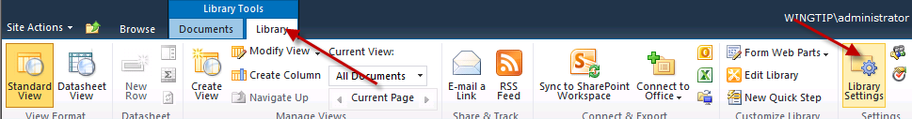

1. Select **Advanced Settings**. At the top of the list, select **Yes** for the **Allow management of content types?** and click **OK**.
2. Next, select **Add from existing site content types** and add the **Product Spec** content type from the **My Doc Sets** group. Remove the default **Document** content type from the list by selecting **Document** and then clicking **Delete this content type**.
3. Next, click **Product Planning** in the breadcrumb navigation. Click the **Documents** tab in the Ribbon, then **New Document » Product Spec**:

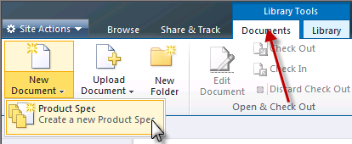

1. Enter the following information in the New Document Set dialog:

**Name:** Slick new widget component

**Program Manager**: Joe Montana

**Lead Developer**: Dan Marino

**Lead Tester**: John Elway

1. The new document set will be represented as a folder. Click the **Slick new widget component** document set to get to the document set’s welcome page:

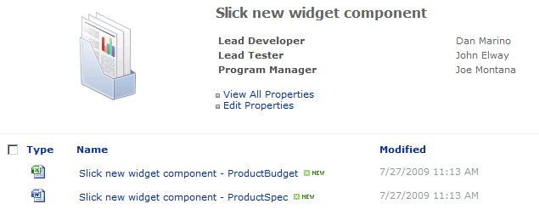

1. From here you can add new content to the document set and edit the properties.
2. Explore the document set management capabilities by clicking on the **Manage Set** tab in the Ribbon. For instance, click the **Download a Copy** button in the Ribbon to have SharePoint package all the documents in the set as well as the metadata into a ZIP and stream it down to your desktop.

In this exercise you created a new document set.